Automated Irrigation System using PID

Do Manh Thang - 20139091, Phan Quyet Thang - 20139050 and Nguyen Vu Tu - 20139094

Faculty of Electrical and Electronics Engineering,

Ho Chi Minh City University of Technology and Education

Ho Chi Minh City, Vietnam.

[thangdo24092002@gmail.com](mailto:Thangdo24092002@gmail.com), [quyetthangmarvel@gmail.com,](mailto:Quyetthangmarvel@gmail.com,) [nguyenvutu010702@gmail.com,](mailto:nguyenvutu010702@gmail.com,)

*Abstract*—This project, titled "Automated Irrigation System," aims to develop an automated system that waters crops based on soil moisture levels. The system is designed to optimize irrigation scheduling and reduce water usage while maximizing crop yields. The project uses a soil moisture sensor to measure the moisture content of the soil and activates a water pump when the moisture level is lower than the set threshold. The system is controlled by a microcontroller, which receives data from the sensor and activates the water pump accordingly. The project demonstrates the potential for low-cost, automated irrigation systems to improve water use efficiency and crop yields in small-scale agriculture.

# Introduction

In this project, we have developed an Automated Irrigation System using a Proportional-Integral-Derivative (PID) algorithm to address the crucial issue of water conservation in agriculture. Agriculture plays a vital role in our society, providing sustenance and livelihoods to millions of people. However, traditional irrigation methods often result in excessive water usage, leading to environmental degradation and the wasteful depletion of precious water resources.

The urgency to implement automated systems stems from the growing concerns surrounding sustainable farming practices. As the global population continues to rise, there is an increasing demand for food production. However, water scarcity and climate change pose significant challenges to traditional farming methods, making it essential to find innovative solutions that can optimize water usage while ensuring healthy crop growth.

Our system addresses these challenges by utilizing a device capable of accurately detecting soil moisture levels. By integrating the PID algorithm, we can precisely control the irrigation process to maintain optimal soil moisture conditions for crops. Extensive research has shown that keeping soil moisture levels within the range of 50-70% is ideal for promoting optimal crop growth and yield.

Furthermore, studies have demonstrated that implementing automated irrigation systems can lead to substantial water savings. It has been reported that such systems can reduce water consumption by up to 40% compared to traditional irrigation methods. This highlights the significant potential for water conservation and resource efficiency offered by automated systems utilizing the PID algorithm.

By automating the irrigation process, our system eliminates the need for manual monitoring and

adjustment, saving farmers valuable time and effort. The PID algorithm continuously analyzes soil moisture data and dynamically adjusts the irrigation based on the specific needs of the crops. This ensures that water is used efficiently, preventing both overwatering and underwatering.

In conclusion, the implementation of an Automated Irrigation System using the PID algorithm represents a vital step towards sustainable agriculture. By conserving water resources, improving crop health, and enhancing farming efficiency, our system addresses the pressing need for water management in agriculture, ensuring a more secure and resilient future for farmers and the environment.

# Motivation

Objectives to be achieved:

1. Monitor soil moisture levels and compare them to the predefined set values.
2. Design a system that regulates the amount of water being irrigated and has the ability to rapidly reduce soil moisture levels.

3. Control the water factor from the environment that affects the moisture within the system, ensuring the system operates with minimal deviation when faced with environmental changes.

# System model

1. *Irrigaion Control System*

Microcontroller (Arduino Uno): An Arduino Uno microcontroller will be employed to process the sensor data, compute the appropriate irrigation control signal, and control the irrigation system.

Soil Moisture Sensor: A sensor will be used to continuously measure the moisture level in the soil. This sensor will provide real-time data on soil moisture, serving as a crucial input for the PID algorithm.

Fan: A fan positioned near the soil surface helps to evaporate excess moisture, reducing soil moisture levels when necessary.

Pump: A water pump is responsible for supplying water to the irrigation system and maintaining the desired moisture setpoint.

PID Control: The microcontroller will process the sensor data and compute the appropriate irrigation control signal using the PID algorithm. The PID algorithm will consider the current moisture level, desired setpoint, and historical data to adjust the water flow accordingly.[1]

1. *System Operation*

Sensing and Data Acquisition: The soil moisture sensor will continuously monitor the moisture level in the soil and send the data to the microcontroller.

PID Control: The microcontroller will process the sensor data and compute the appropriate irrigation control signal using the PID algorithm. The PID algorithm will consider the current moisture level, desired setpoint, and historical data to adjust the water flow accordingly.

PID (Proportional-Integral-Derivative) control is a widely used control algorithm in various fields, including automation, robotics, and process control. It aims to regulate a system's output by continuously adjusting a control variable based on the difference between the desired setpoint and the actual measured value. [3]

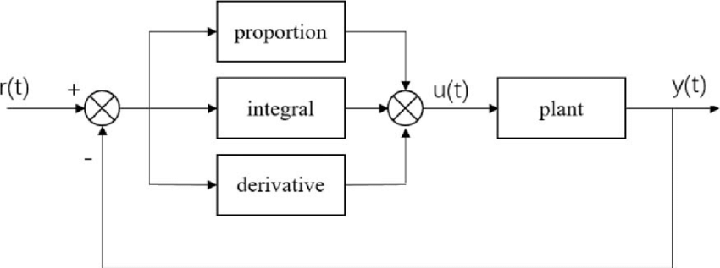

*Fig. 1: PID Structure*

Actuation: The microcontroller will adjust the motor speed based on the deviation between the current soil moisture and the initial setpoint. The motor controls the water flow rate to regulate the irrigation process. If the soil moisture deviates from the setpoint, the motor speed will be increased or decreased accordingly to maintain the desired moisture level.

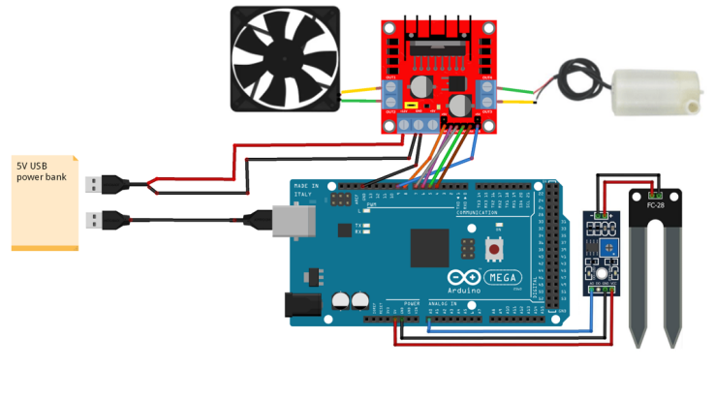

*Fig. 2: Connection Diagram*

# Implementation

In this section we will specify the sensors and the actuators that are used to counteract the measure provided by the specific sensors.

1. *Hardware Setup*

* Connect the soil moisture sensor (SMS-V1) to the analog input pin of the Arduino Uno. [4]
* Connect the motor and fan to the L298N motor driver module.
* Connect the L298N motor driver module to the Arduino Uno using appropriate wiring. [5]
* Connect the water pump to the power supply and ensure it is capable of providing the required water flow.[2]

1. *Software Development*

Set up the Arduino Uno development environment.

Write the code to read the sensor data from the soil moisture sensor.

Implement the PID algorithm in the code to calculate the irrigation control signal based on the deviation between the current soil moisture and the desired setpoint.

Write the code to control the motor speed and adjust the water flow rate accordingly.

Incorporate the necessary logic to activate the fan for evaporation control when required.

Upload the code to the Arduino Uno.

1. *System Calibration*

Place the soil moisture sensor in the soil of a test plant.

Set the desired moisture setpoint for the plant's growth stage (**65% moisture content**).

Run the system and monitor the sensor readings.

Adjust the PID parameters if necessary to achieve accurate and stable control of the soil moisture.

Fine-tune the motor speed control to ensure the desired moisture setpoint is maintained within the acceptable range.

1. *Real-World Testing and Validation*

Conduct practical experiments with different types of soil and crops to evaluate the system's data collection capabilities and its ability to adjust irrigation based on the PID algorithm.

Install the system in a farming area and connect the sensors, actuators, and the Arduino Uno.

Monitor and record the soil moisture levels and observe how the system responds in real-time.

Assess the system's accuracy in collecting data and its effectiveness in adjusting irrigation based on the PID algorithm.

Analyze the collected data to evaluate the system's performance and identify any areas for improvement.

Make necessary adjustments to the PID algorithm or system parameters based on the testing results.

Repeat the testing process to validate the system's improvements and ensure its reliability and efficiency.

1. *Integration and Deployment*

Install the system in the target farming area, connecting the sensors, actuators, and the Arduino Uno.

Ensure proper power supply and protection measures are in place.

Set up a user interface, if desired, to monitor and control the system remotely.

Train the users on how to operate and maintain the system.

Monitor the system's performance regularly and make any required adjustments or maintenance as needed.

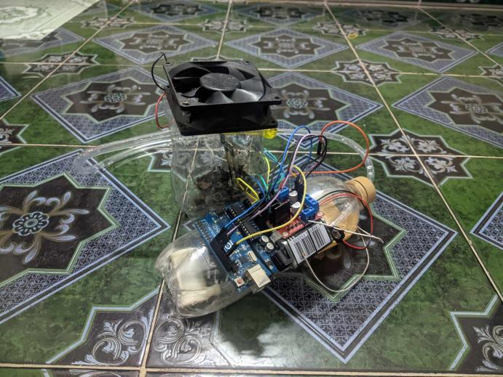

*Fig. 3: Automated Irrigation System Complete Setup*

# Limitation

Throughout the course of our project, we encountered several limitations during the implementation of the physical system. Firstly, it is important to acknowledge that not all plant species have the same water requirements. The default settings of our system, which assume a moisture setpoint of 65%, may not be optimal for every type of crop or vegetation. It is crucial to consider the specific water needs of different plants and adjust the system parameters accordingly to ensure efficient water management.

Another limitation we encountered relates to the soil moisture sensors. While these sensors provide valuable data, they require regular calibration to maintain accuracy. Factors such as sensor drift, environmental conditions, and soil buildup can affect the performance of the sensors over time. Therefore, regular calibration and maintenance are necessary to ensure reliable and precise measurements.

Additionally, it is important to note that not all plant species require a soil moisture level of 65%. Different plants thrive in different soil moisture conditions, and their optimal moisture levels can vary significantly. Therefore, it is crucial to consider the specific requirements of the plants being cultivated and adjust the moisture setpoint accordingly to ensure their healthy growth.

Furthermore, a limitation we faced is the reliance on an external 9V battery as the power source for our system. It became evident that the battery's capacity might not be sufficient for prolonged operation of the irrigation control system. To overcome this limitation, we recommend implementing a low voltage power supply sourced from the mains electricity. This would provide a continuous and reliable power source, ensuring uninterrupted operation of the system.

By addressing these limitations, such as considering plant-specific water requirements, performing regular

sensor calibration, and improving the power supply, we can enhance the effectiveness and efficiency of the irrigation control system. It is important to tailor the system to meet the specific needs of different plant species and ensure reliable operation in the long term.

# Solutions and future work

In the future, there are several potential improvements and advancements that can be applied to enhance the irrigation control system, including the integration of IoT (Internet of Things) technology. Here are some possible enhancements:

1. IoT Connectivity: By incorporating IoT technology, the system can be connected to the internet, enabling remote monitoring and control. Real-time data on soil moisture levels, temperature, and other environmental parameters can be collected and transmitted wirelessly to a centralized platform. This allows for convenient monitoring and control of the irrigation system from anywhere, providing farmers or users with greater flexibility and accessibility.

2. Data Analytics and Machine Learning: With IoT connectivity, collected data can be analyzed using advanced analytics techniques and machine learning algorithms. By analyzing historical data and patterns, the system can learn and adapt to optimize irrigation schedules and water usage. Machine learning algorithms can identify correlations between environmental factors and plant health, leading to more precise irrigation strategies tailored to specific plant species and growth stages.

3. Automated Decision-making: By combining IoT data, sensor readings, and advanced algorithms, the system can automate decision-making processes. For example, based on real-time weather forecasts, the system can adjust irrigation schedules to account for upcoming rainfall, minimizing water waste. It can also analyze plant growth patterns and adjust irrigation parameters accordingly, optimizing water usage while promoting plant health.

4. Smart Water Management: Integrating water management technologies, such as flow sensors and smart valves, can provide more precise control over water usage. These devices can detect leaks, monitor water flow, and regulate water distribution based on plant needs and soil moisture levels. This helps conserve water resources and ensures efficient water delivery to the plants.

5. Mobile Applications and Alerts: Developing user-friendly mobile applications can provide farmers or users with convenient access to monitor and control the irrigation system. Notifications and alerts can be sent to users' smartphones, informing them of critical events such as low soil moisture levels, equipment malfunctions, or maintenance requirements.

1. Energy Optimization: Exploring energy-efficient solutions, such as solar power or energy harvesting techniques, can reduce the system's reliance on external power sources. This promotes sustainability and

cost-effectiveness by utilizing renewable energy sources for long-term operation.

Implementing these future enhancements would enable a more intelligent, efficient, and sustainable irrigation control system. By leveraging IoT connectivity, data analytics, and automation, farmers and users can make informed decisions, conserve water resources, optimize plant growth, and ultimately achieve better agricultural productivity.

# Conclusion

In conclusion, the developed irrigation control system has shown promising results in efficiently managing water resources for plant cultivation. However, it is important to acknowledge the limitations and areas for improvement. The system's default settings may not be suitable for all plant species and environmental conditions, highlighting the need for customization based on specific crop requirements. Additionally, regular calibration and maintenance of soil moisture sensors are essential to ensure accurate measurements.

To further enhance the system, future improvements can include the integration of IoT technology for remote monitoring and control, data analytics and machine learning for optimized irrigation strategies, automated decision-making processes, smart water management technologies, user-friendly mobile applications, and exploration of energy optimization techniques.

By addressing these limitations and embracing future advancements, the irrigation control system can become more intelligent, efficient, and sustainable, enabling farmers and users to achieve better agricultural productivity while conserving water resources.

# References

1. Shoba Krishnan, Kalyani Lakkanige, Ragini Ananthakrishnan, Dhaneesh Virwani, Vishal Laungani, “Automated Irrigation Systems: Challenges and Opportunities” 2020 IEEE, pp 1 - 4 (2020)
2. Macha Pavani1, Dr. K. Hemachandran, H.Raghupathi (HOD), “Design and Implemantation of Automated Irrigation System in Agriculture using Wireless Sensor Network” 2017 IEEE, pp 1 - 7 (2017)
3. Favour Adenugba, Sanjay Misra, Rytis Maskeliūnas, Robertas Damaševičius and Egidijus Kazanavičius, “Smart irrigation system for environmental sustainability in Africa: An Internet of Everything (IoE) approach” 2019 IEEE, pp 1 - 6 (2019)
4. <https://docs.arduino.cc/static/393d49477d4a02c437dc3ee947215b64/A000066-datasheet.pdf>
5. https://www.sparkfun.com/datasheets/Robotics/L298_H_Bridge.pdf